**aero**

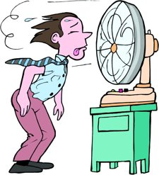**Needing Oxygen or Air**

[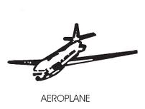](http://www.google.com/imgres?q=aeroplane&start=294&hl=en&biw=1008&bih=456&tbm=isch&tbnid=DhXHmNdvbDpz2M:&imgrefurl=http://commons.wikimedia.org/wiki/File:ECI-aeroplane.png&docid=JklyvJpOY9isYM&imgurl=http://upload.wikimedia.org/wikipedia/commons/c/c6/ECI-aeroplane.png&w=253&h=192&ei=JultUdWhGI229gSWhYCYBw&zoom=1&ved=1t:3588,r:97,s:200,i:295&iact=rc&dur=481&page=27&tbnh=153&tbnw=202&ndsp=10&tx=82&ty=95)