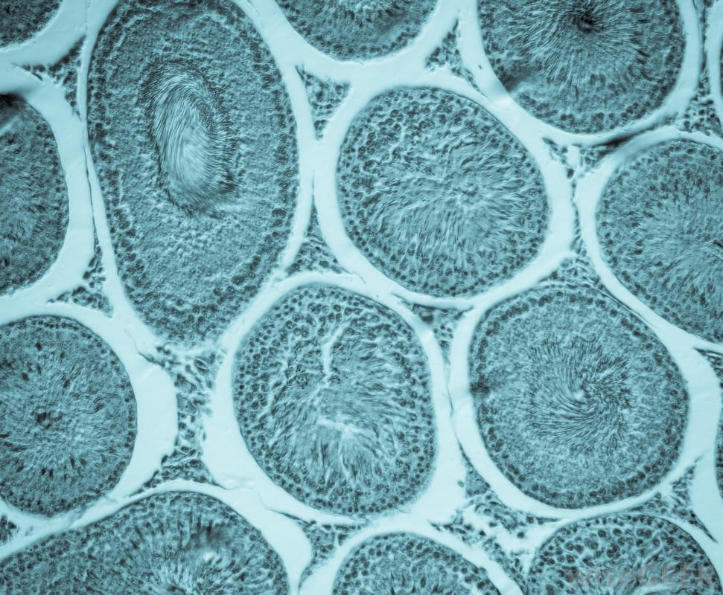

**Indicating or involving life or living organisms**

BIO-